**TRANSPORTATION – TRAFFIC CONGESTION PREDICTION FROM IOT SENSORS**

**A PROJECT REPORT**

***Submitted by***

**KAVIYA P 2116231801082**

**MONISHA KR 2116231801111**

**AKASH K 2116231801509**

***in partial fulfillment for the award of the degree of***

**BACHELOR OF TECHNOLOGY**

**IN**

**ARTIFICIAL INTELLIGENCE AND DATA SCIENCE**



**RAJALAKSHMI ENGINEERING COLLEGE (AUTONOMOUS), CHENNAI – 602 105**

**OCTOBER 2025**

**BONAFIDE CERTIFICATE**

Certified that this Report titled “ **TRANSPORTATION – TRAFFIC CONGESTION PREDICTION FROM IOT SENSORS**” is the Bonafide work of “**KAVIYA P (2116231801082) MONISHA KR (2116231801111) AKASH K (2116231801509)”** who carried out the work

under my supervision. Certified further that to the best of my knowledge the work reported herein does not form part of any other thesis or dissertation on the basis of which a degree or award was conferred on an earlier occasion on this or any other candidate.

**Dr. Suresh Kumar S M.E., Ph.D.,**

**Professor,**

Department of Artificial Intelligence & Data Science,

Rajalakshmi Engineering College

Thandalam – 602 105.

Submitted to Project Viva-Voce Examination held on

**Internal Examiner External Examiner**

# ACKNOWLEDGEMENT

Initially I thank the Almighty for being with us through every walk of my life and showering his blessings through the endeavor to put forth this report.

My sincere thanks to our Chairman **Mr. S. MEGANATHAN, M.E., F.I.E.,** and our Chairperson **Dr. (Mrs.) THANGAM MEGANATHAN, M.E., Ph.D.,** for providing me with the requisite infrastructure and sincere endeavoring educating me in their premier institution.

My sincere thanks to **Dr. S.N. MURUGESAN M.E., Ph.D.,** our beloved Principal for his kind support and facilities provided to complete our work in time.

I express my sincere thanks to **Dr. J M Gnanasekar M.E., Ph.D.,** Head of the Department of Artificial Intelligence and Data Science for his guidance and encouragement throughout the project work. I convey my sincere and deepest gratitude to our internal guide, **Dr. Suresh Kumar S M.E., Ph.D.,** Professor, Department of Artificial Intelligence and Data Science, Rajalakshmi Engineering College for his valuable guidance throughout the course of the project.

Finally, I express my gratitude to my parents and classmates for their moral support and valuable suggestions during the course of the project.

### KAVIYA P MONISHA KR AKASH K

### (2116231801082) (2116231801111) (2116231801509)

### 

### ****Abstract****

The rapid growth of urbanization has led to a significant increase in vehicle density, resulting in severe traffic congestion and reduced transportation efficiency. Traditional traffic management systems are often reactive and limited in scalability, making it difficult to predict and mitigate congestion effectively. This project, **"Transportation – Traffic Congestion Prediction from IoT Sensors,"** proposes a big data–driven solution to predict traffic congestion in real time using Internet of Things (IoT) sensor data.

The system leverages a distributed big data architecture to collect, store, process, and analyze high-velocity traffic data generated by IoT sensors such as GPS devices, RFID tags, traffic cameras, and road-embedded sensors. Data preprocessing and streaming analytics are performed using technologies like Apache Kafka, Spark Streaming, and Hadoop for large-scale batch and real-time processing. Machine learning algorithms are applied to the processed data to forecast traffic congestion levels, enabling authorities to implement proactive control measures such as dynamic traffic signal adjustment and route optimization.

This architecture ensures scalability, fault tolerance, and low-latency data handling, making it suitable for smart city implementations. The project demonstrates how the integration of IoT and big data analytics can transform traditional transportation systems into intelligent, data-driven infrastructures, ultimately improving urban mobility, reducing travel time, and minimizing environmental impact.

The proposed system not only focuses on congestion prediction but also emphasizes the importance of data-driven decision-making in urban transportation planning. By continuously learning from real-time and historical traffic patterns, the model can adapt to changing conditions such as weather variations, road accidents, or public events that affect traffic flow. Furthermore, the integration of visualization dashboards allows stakeholders, including traffic authorities and city planners, to monitor congestion trends and make informed decisions. This project highlights how combining IoT technologies, big data frameworks, and predictive analytics can pave the way for smarter, safer, and more sustainable urban transportation ecosystems.

**TABLE OF CONTENTS**

**CHAPTER NO NAME PAGE NO**

### Background 7

### Motivation 7

### Objectives 8

### Problem Statement 8

### Scope of the Project 9

### 2.1 Traditional Methods 10

### 2.2 Statistical and Rule-Based 10

### Techniques

### 2.3 Machine Learning 11

### 2.4 Big Data and Cloud-Based 11

### Approach

### 2.5 Anomaly Detection 12

### 2.6 Summary of Research Gaps 12

### 2.7 Contribution of the present 13 work

### 3.1 System Overview 14 3.2 System Architecture 14

### 3.3 System Requirment

### 3.3.1 Hardware 15

### 3.3.2 Software 16

### 

### 3.4 System Modules 16

### 3.5 Data Flow Diagram 17

### 3.6 Summary 17

### 4.1 Data Collection Module 18 4.2 Data Preprocessing Module 18

### 4.3 Hive Query & Hive Table 18

### Creation

### 4.4 Visualization Module 21

### 4.5 Dashboard Module 22

### 5.0 Implementation 23

### 6.0 Result 24

### 7.0 Conclusion 25

### 8.0 Future enhancement 26

### References 27

### 

**FIGURE NO NAME PAGE NO**

1. **Big Data–Based Energy 13  
   Theft Detection Architecture   
   on Google Cloud Platform**
2. **Analysis Dashboard 24**

**CHAPTER 1**

**INTRODUCTION**

### ****1.1 Background****

In recent years, the exponential increase in vehicle ownership has caused severe traffic congestion in urban areas worldwide. This congestion not only leads to longer travel times and fuel wastage but also contributes significantly to environmental pollution and stress among commuters. Traditional traffic management systems rely heavily on manual monitoring or static sensor data, which limits their ability to respond effectively to dynamic traffic patterns. With the emergence of the Internet of Things (IoT), vast amounts of real-time traffic data can now be captured through interconnected sensors such as GPS trackers, road cameras, and vehicle detectors.

However, managing and analyzing this massive, continuous data stream requires scalable and efficient big data architecture. By integrating IoT technologies with big data analytics, it becomes possible to predict congestion patterns and enable proactive traffic control. This convergence has become a crucial step toward building intelligent transportation systems that can enhance urban mobility and sustainability.

### ****1.2 Motivation****

Urbanization and population growth have placed immense pressure on existing transportation infrastructure. Traffic congestion leads to wasted time, increased fuel consumption, air pollution, and economic losses. Current reactive systems can only respond after congestion occurs, rather than preventing it. Therefore, there is a strong need for a predictive system that can forecast traffic conditions before congestion becomes critical.

The motivation behind this project lies in leveraging IoT-generated data and advanced big data analytics to provide actionable insights in real time. By using scalable data processing platforms and machine learning algorithms, cities can move toward smarter traffic management—reducing delays, optimizing routes, and improving overall quality of life. The project also aims to demonstrate the effectiveness of big data architectures in handling large-scale, heterogeneous sensor data efficiently.

### ****1.3 Objectives****

The main objective of this project is to design and implement a big data–driven framework capable of predicting traffic congestion using data collected from IoT sensors deployed across transportation networks. The system aims to efficiently handle large volumes of heterogeneous data generated by sources such as GPS devices, traffic cameras, and road sensors, enabling real-time monitoring and analysis of traffic conditions. By applying machine learning algorithms to this data, the project seeks to forecast congestion levels accurately and provide early warnings to traffic management authorities. Furthermore, the project aims to develop an interactive visualization dashboard that presents traffic trends, congestion hotspots, and predictive insights in a user-friendly manner. Ultimately, the goal is to improve traffic flow, reduce travel delays, enhance urban mobility, and support the development of intelligent and sustainable smart city transportation systems.

### ****1.4 Problem Statement****

With the continuous rise in urban population and vehicle ownership, city roads are becoming increasingly congested, leading to serious challenges in traffic management. Traditional traffic control systems rely on static data sources and manual interventions, which are insufficient for handling dynamic, real-time traffic variations. These systems lack predictive capabilities and often respond to congestion only after it occurs, resulting in delays, higher fuel consumption, increased pollution, and reduced transportation efficiency.

The main problem addressed in this project is the **lack of an intelligent, data-driven system** that can utilize real-time IoT sensor data to **predict and prevent traffic congestion** before it happens. Managing and analyzing massive, continuous data streams from IoT devices requires a scalable big data architecture capable of processing, storing, and analyzing high-velocity traffic data efficiently. Therefore, the challenge lies in developing an integrated framework that combines IoT sensing, big data analytics, and machine learning techniques to deliver accurate, real-time traffic congestion predictions and support smarter urban mobility management.

Urban areas around the world are facing severe traffic congestion due to the rapid increase in vehicle numbers and inadequate real-time traffic management systems. Existing traffic control mechanisms are largely reactive, relying on limited and static data sources, which makes it difficult to predict and mitigate congestion effectively. The absence of an intelligent system that can process and analyze the massive, continuous data generated by IoT sensors leads to inefficient traffic flow, longer travel times, and increased fuel consumption. Therefore, there is a critical need for a big data–based predictive model capable of utilizing IoT sensor data to forecast traffic congestion in real time, enabling proactive decision-making and improving overall transportation efficiency in smart cities.

### ****1.5 Scope of the Project****

The scope of this project encompasses the design and implementation of a big data architecture for real-time traffic congestion prediction using IoT sensor data. The system focuses on collecting traffic-related data from multiple IoT-enabled sources such as GPS devices, surveillance cameras, and road sensors, and then processing this data through scalable big data frameworks. The project includes modules for data ingestion, storage, real-time stream processing, machine learning–based prediction, and visualization of congestion patterns.

The system is designed to handle both historical and streaming data, allowing continuous learning and adaptive prediction of traffic conditions. The project also demonstrates how integrating IoT technologies with big data analytics can enhance the efficiency of traffic management systems, support data-driven decision-making, and contribute to the development of smart city infrastructure. However, the project is limited to the analytical and architectural level, focusing on simulation and prototype implementation rather than large-scale citywide deployment.

In addition to congestion prediction, the project also aims to explore the potential of integrating advanced analytics and visualization tools for effective traffic monitoring and management. The system can be extended to support decision-making processes such as traffic signal control, route optimization, and emergency vehicle prioritization. By using cloud-based and distributed data processing technologies, the architecture can be scaled to accommodate larger datasets and broader geographic areas. This makes the proposed system adaptable for future enhancements, including integration with other smart city applications like public transportation management, accident detection, and environmental monitoring, thereby contributing to a comprehensive intelligent transportation ecosystem.

The project’s scope also extends to evaluating the performance of different big data tools and machine learning models to identify the most efficient techniques for real-time traffic prediction. It emphasizes scalability, reliability, and low-latency processing to ensure timely insights for traffic management authorities. Although the system is developed as a prototype, it lays the foundation for future large-scale deployment in smart cities, demonstrating the practical application of IoT and big data technologies in solving real-world transportation challenges.

**CHAPTER 2**

**LITERATURE SURVEY**

The prediction of traffic congestion has become a vital research area due to its direct impact on urban mobility, energy consumption, and environmental sustainability. Over the years, various methods have been proposed — ranging from traditional statistical and rule-based models to advanced machine learning and, more recently, Big Data–driven predictive systems. With the increasing deployment of IoT sensors in transportation networks, vast amounts of real-time data are now available for analysis, enabling more accurate and dynamic congestion forecasting. This chapter reviews the most significant studies and approaches in this domain, outlining their methodologies, advantages, limitations, and the technological evolution that has led to the development of Big Data–based intelligent traffic management systems.

### ****2.1 Traditional Methods****

Traditional traffic management systems relied primarily on manual observation, loop detectors, and fixed-time signal control mechanisms. Data collection was typically done through roadside surveys, pneumatic tubes, or traffic cameras, providing only limited and periodic information about vehicle movement. These methods offered basic insights but lacked the capacity to process or analyze large-scale, continuous data streams in real time.

In most cases, decisions were based on historical averages rather than live conditions, leading to inefficiencies during sudden changes such as road accidents or weather disruptions. The static nature of these systems meant that traffic signal timing and route control were often predefined and non-adaptive, causing unnecessary delays and congestion during peak hours.

While traditional methods served as the foundation for early traffic studies, they were unable to handle the explosive growth in data volume and velocity associated with modern transportation systems. This limitation led researchers to explore more automated, data-centric, and scalable solutions capable of handling continuous information from multiple sources — paving the way for big data–based traffic management architectures.

### ****2.2 Statistical and Rule-Based Techniques****

Before the emergence of big data technologies, statistical and rule-based approaches were widely used for traffic prediction. Methods such as linear regression, autoregressive integrated moving average (ARIMA), and Markov models attempted to model traffic flow based on historical datasets. These models worked well for small datasets and predictable traffic patterns but struggled when data became high-dimensional or nonlinear.

Rule-based systems used a predefined set of conditions or thresholds, such as vehicle count limits or speed thresholds, to trigger alerts or actions. Although easy to implement, these systems lacked adaptability and scalability, as they were not capable of learning from evolving traffic behavior or processing streaming data in real time.

While statistical and rule-based models offered foundational insights into traffic prediction, they were inherently limited by their dependence on structured, static datasets. The growing complexity of urban transportation required more robust solutions capable of integrating heterogeneous data sources, handling large-scale information, and dynamically updating predictive models — characteristics better supported by big data architectures.

### ****2.3 Machine Learning Approaches****

The integration of machine learning (ML) into traffic prediction marked a major step forward in intelligent transportation systems. ML algorithms such as Random Forests, Support Vector Machines (SVM), and Neural Networks have been applied to model complex relationships between traffic variables like speed, density, and flow. These algorithms can detect hidden patterns in large datasets and adapt to changing traffic dynamics.

Deep learning techniques, including Convolutional Neural Networks (CNNs) and Recurrent Neural Networks (RNNs), have further enhanced the ability to capture both spatial and temporal dependencies within traffic data. For instance, CNNs can analyze traffic images from cameras, while RNNs can predict future traffic conditions based on sequential sensor data. However, these approaches demand massive amounts of high-quality data and computational resources.

To meet these requirements, the implementation of ML models has increasingly been supported by big data frameworks such as Apache Spark MLlib and TensorFlow on distributed platforms. These integrations have enabled scalable and faster training of models using IoT-generated traffic data, making predictive analytics more practical and efficient for large-scale deployment.

### ****2.4 Big Data and Cloud-Based Approaches****

Big data technologies have revolutionized the way traffic data is collected, processed, and analyzed. Frameworks such as Hadoop, Spark, Kafka, and Flink allow for the distributed handling of massive datasets generated by IoT sensors, GPS trackers, and vehicle communication systems. These platforms provide high-throughput, fault-tolerant processing and enable real-time data streaming and analysis.

Cloud computing complements big data by offering elastic storage and computational power through platforms like AWS, Azure, and Google Cloud. These environments support scalable data pipelines and integrate seamlessly with analytics tools to process both historical and real-time data. Cloud-based architectures also facilitate cross-system data sharing, making them ideal for large-scale intelligent transportation systems.

Together, big data and cloud technologies form the backbone of modern traffic prediction architectures. They enable continuous data ingestion, real-time processing, and predictive analytics — supporting decision-making processes such as dynamic route planning, congestion control, and infrastructure optimization. This integrated approach has become essential for managing the complexity of urban transportation networks.

### ****2.5 Anomaly Detection Techniques****

In the context of traffic prediction, anomaly detection is essential for identifying sudden irregularities such as accidents, road closures, or unusual congestion patterns. Big data architectures allow anomaly detection algorithms to operate on streaming data in real time, detecting outliers across vast data flows from IoT devices. Techniques such as clustering, isolation forests, and autoencoders are commonly used for identifying such anomalies.

Modern systems integrate anomaly detection within distributed big data frameworks to ensure low-latency processing and rapid alerting. For instance, Apache Spark Streaming and Kafka Streams can continuously monitor incoming data, applying statistical or machine learning models to detect deviations from normal traffic behavior.

By combining anomaly detection with predictive analytics, big data–based systems not only forecast congestion but also react adaptively to unexpected disruptions. This dual capability enhances reliability and makes the architecture more resilient, providing traffic authorities with real-time intelligence for quick response and effective traffic control.

### ****2.6 Summary of Research Gaps****

While numerous studies have explored traffic prediction using statistical, machine learning, and big data techniques, several challenges remain unresolved. Many existing systems either focus solely on data analytics or on IoT integration, without establishing a complete end-to-end architecture that bridges data collection, storage, processing, and predictive modeling.

Furthermore, scalability and latency issues persist when handling continuous IoT data streams. Some models lack robustness in processing unstructured data from heterogeneous sources such as images, sensors, and GPS signals. Additionally, there is limited research on integrating anomaly detection with predictive analytics in a unified big data environment.

These gaps highlight the need for a comprehensive big data architecture that seamlessly integrates IoT data ingestion, distributed processing, machine learning analytics, and visualization. Such an approach would enable real-time, scalable, and adaptive traffic management for smart city applications.

### ****2.7 Contribution of the Present Work****

The present work aims to design and implement a **Big Data Architecture for Traffic Congestion Prediction using IoT Sensors** that addresses the identified research gaps. The proposed system integrates multiple components — IoT-based data collection, real-time data ingestion via Apache Kafka, distributed processing using Apache Spark and Hadoop, and predictive analytics using machine learning models.

This architecture demonstrates how IoT data can be processed efficiently through a scalable pipeline to generate timely congestion predictions and anomaly alerts. Additionally, the project includes a visualization dashboard that presents congestion patterns and predictive insights, assisting traffic authorities in making informed, proactive decisions.

Overall, this work contributes to the advancement of smart transportation systems by providing a holistic, scalable, and data-driven framework. It showcases how the fusion of IoT, big data technologies, and predictive analytics can transform traditional traffic management into an intelligent, automated, and sustainable urban mobility solution.

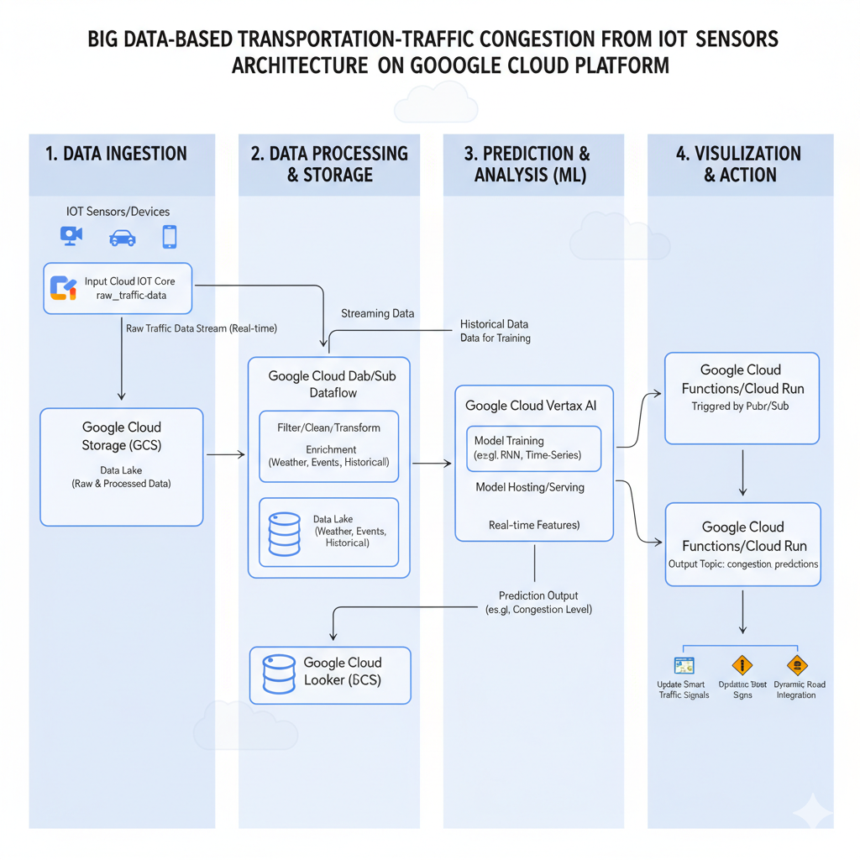

**Figure 1: Big Data–Based on traffic congestion from IOT sensors architecture on Google Cloud Platform**

**CHAPTER 3**

**SYSTEM ANALYSIS AND DESIGN**

This chapter explains the overall architecture, system requirements, and module design of the **Traffic Congestion Prediction System**. The goal of the system is to analyze large-scale traffic data collected from IoT-based sensors and predict congestion patterns using Big Data analytics and machine learning techniques.  
The system leverages **Google Cloud Platform (GCP)** for data ingestion, processing, storage, and visualization within a fully integrated and scalable architecture. By utilizing services such as **Cloud IoT Core**, **Dataflow**, **BigQuery**, **Vertex AI**, and **Looker Studio**, the system enables real-time monitoring and prediction of traffic flow, helping improve urban mobility and support smart transportation management.

### ****3.1 System Overview****

The proposed system focuses on predicting traffic congestion using data generated from IoT sensors deployed across transportation networks. With the rapid increase in vehicular movement and urbanization, traditional traffic control systems have proven insufficient for handling real-time data at scale. The proposed solution leverages a Big Data–driven architecture that can collect, store, process, and analyze high-velocity traffic data to generate accurate and timely predictions.

This system integrates IoT sensors, cloud-based data pipelines, and machine learning models to enable dynamic congestion forecasting. Data from multiple sources such as GPS devices, cameras, and environmental sensors is continuously ingested and processed on the Google Cloud Platform (GCP). By applying advanced analytics and predictive models, authorities can proactively manage traffic signals, optimize routes, and minimize congestion.

The architecture ensures scalability, real-time responsiveness, and fault tolerance through distributed data processing and cloud-native services. Using Google Cloud’s ecosystem, the system supports end-to-end automation from data collection to visualization and actionable insights providing an intelligent, data-driven approach to traffic management within smart city environments.

### ****3.2 System Architecture****

The Big Data architecture designed for this project is composed of four major layers: **Data Ingestion**, **Data Processing and Storage**, **Prediction and Analysis**, and **Visualization and Action**. Each layer performs a distinct role in handling large-scale, real-time traffic data. IoT sensors act as the primary data sources, continuously sending raw traffic streams to the Google Cloud IoT Core for ingestion. This data includes parameters like vehicle count, speed, and environmental conditions.

### ****1. Data Ingestion Layer****

Traffic-related data is continuously collected from various IoT-enabled devices such as GPS sensors, traffic cameras, RFID systems, and vehicle detectors deployed across the transportation network. These data streams include parameters such as vehicle count, speed, density, and road occupancy. The collected data is securely ingested into **Google Cloud IoT Core** and streamed to **Google Cloud Storage (GCS)** under a designated “raw_traffic_data” bucket (e.g., gs://traffic-congestion-project/raw/). This layer ensures real-time, scalable, and reliable ingestion of heterogeneous data from distributed IoT sources, forming the foundation for all downstream analytics.

### ****2. Data Processing Layer (Data Engineering)****

The raw data ingested from IoT devices is processed using **Google Cloud Dataflow** and **Pub/Sub** for real-time data streaming, filtering, and transformation. This stage involves cleaning incomplete or inconsistent entries, aggregating data by time intervals, and enriching it with contextual information such as weather conditions, road events, and public holidays. The processed and enriched data is stored in **Google Cloud Storage (GCS)** under a “processed” directory (e.g., gs://traffic-congestion-project/processed/). This layer ensures high-quality, structured datasets ready for predictive analytics and machine learning.

### ****3. Storage and Analytics Layer****

The refined datasets are then loaded into **BigQuery**, Google’s serverless data warehouse, for large-scale analytical querying and pattern discovery. Within this layer, historical traffic data is analyzed using SQL queries to extract key metrics such as average congestion duration, vehicle flow rate, and incident frequency. The data also serves as input for training predictive models hosted in **Google Cloud Vertex AI**, where time-series and deep learning algorithms (e.g., RNN, LSTM) are used to forecast future congestion levels. BigQuery supports both ad-hoc analytics and real-time model integration, ensuring a seamless analytical workflow.

### ****4. Visualization and Action Layer****

The prediction outputs and analytics insights are visualized using **Google Looker Studio**, providing interactive dashboards, charts, and congestion heatmaps. These visualizations display real-time congestion trends, predicted traffic levels, and historical performance comparisons. Additionally, **Google Cloud Functions** or **Cloud Run** services are triggered automatically to send alerts or update connected systems such as **smart traffic signals** and **digital road signs**. This layer transforms predictive insights into actionable responses, allowing transportation authorities to manage congestion proactively and improve traffic flow efficiency.

### ****3.3 System Requirements****

#### **3.3.1 Hardware Requirements**

The system is designed to operate on cloud infrastructure, minimizing local hardware dependencies. However, IoT sensors are essential components for data collection, including GPS trackers, inductive loop detectors, and environmental sensors installed along road networks. These devices continuously capture parameters like vehicle speed, density, and weather conditions.

For backend operations, a standard computing device with internet access

is required for administrative control, data monitoring, and dashboard interaction. While Google Cloud provides the computational backbone, local machines used by system operators should have at least 8 GB RAM, a quad-core processor, and stable network connectivity to ensure smooth operation.

Edge devices or gateways may also be used near data sources to preprocess or compress traffic data before cloud transmission. These devices improve efficiency and reduce latency by performing preliminary data validation and packaging at the source.

#### **3.3.2 Software Requirements**

The software stack primarily relies on Google Cloud services to enable Big Data processing, analytics, and visualization. **Google Cloud IoT Core** is used for secure device connectivity and data ingestion, while **Pub/Sub** and **Dataflow** handle data streaming and transformation. **Google Cloud Storage (GCS)** serves as the data lake for storing both raw and processed traffic data.

For predictive analytics, **Google Cloud Vertex AI** provides an integrated environment for model training, deployment, and real-time inference. The visualization and decision-making interface is powered by **Google Looker Studio** and **Google Cloud Functions**, which automate traffic signal adjustments and generate actionable alerts.

Programming and configuration are primarily handled using Python, SQL, and TensorFlow for machine learning models. Additional services like **BigQuery** may be integrated for large-scale data querying and performance optimization. Together, these tools create a unified, scalable Big Data ecosystem that supports end-to-end congestion prediction.

### ****3.4 System Modules****

The proposed system is divided into four major modules, each corresponding to a functional layer in the Big Data architecture. The **Data Ingestion Module** collects and streams traffic data from IoT devices to Google Cloud IoT Core. This ensures secure, real-time transmission of data from distributed sensors and mobile devices deployed across the transportation network.

The **Data Processing Module** is responsible for data cleaning, transformation, and enrichment using Google Cloud Dataflow and Pub/Sub. Here, redundant and incomplete data is filtered out, and external datasets such as weather and event data are merged for contextual accuracy. The processed data is stored in Google Cloud Storage, forming a central data lake that supports both real-time and historical analysis.

The **Prediction and Visualization Module** uses machine learning models hosted on Google Cloud Vertex AI to forecast congestion levels. Predicted results are visualized through Google Looker dashboards, while Google Cloud Functions automate responses—such as updating digital traffic signs or adjusting signal timing. Together, these modules form a continuous, self-learning system capable of delivering accurate, actionable insights for smart traffic management.

### ****3.5 Data Flow Diagram (DFD)****

**Level 0 DFD:**  
User → IoT Sensors → Google Cloud IoT Core → Google Cloud Storage (GCS) → Dataflow / Pub/Sub → BigQuery → Vertex AI → Looker Studio → Visualization Output

**Level 1 DFD:**

1. **Data Collection →** IoT sensors and devices continuously collect live traffic data (vehicle count, speed, density, and environmental factors) and send it to Google Cloud IoT Core for ingestion.
2. **Data Cleaning & Transformation →** Dataflow and Pub/Sub perform real-time cleaning, filtering, and enrichment with contextual data such as weather and events.
3. **Processed Data →** The transformed and enriched data is stored in Google Cloud Storage (Processed Data Bucket).
4. **Model Training & Analytics →** BigQuery provides analytical querying, while Vertex AI trains and deploys predictive models for congestion forecasting.
5. **Visualization & Alerts →** Google Looker Studio visualizes congestion trends, and Cloud Functions trigger automated updates to smart traffic systems based on predictions.

### ****3.6 Summary****

The proposed system is designed as a **scalable Big Data architecture** deployed on **Google Cloud Platform**, capable of efficiently processing large volumes of real-time traffic data from IoT sensors. The architecture integrates services such as Google Cloud IoT Core, Dataflow, BigQuery, Vertex AI, and Looker Studio to deliver a unified pipeline for data ingestion, analytics, and visualization.

### CHAPTER 4

### MODULES DESCRIPTION

### ****4.1 Data Collection Module****

The **Data Collection Module** is responsible for gathering real-time traffic data from various IoT-enabled sources such as GPS devices, road-side sensors, traffic cameras, and vehicle detection systems. These sensors continuously capture parameters including vehicle count, average speed, traffic density, and road occupancy across multiple locations. The collected data is transmitted through the IoT network and ingested into the cloud using **Google Cloud IoT Core** for secure and reliable data transfer.

All incoming data streams are stored in **Google Cloud Storage (GCS)** within a designated “raw data” bucket, forming the foundation for subsequent analysis. This layer ensures the scalability and consistency of data ingestion, enabling continuous data flow from distributed devices deployed across smart city infrastructures. The module’s design guarantees high availability and real-time integration with other system components for immediate data processing.

### ****4.2 Data Preprocessing Module****

The **Data Preprocessing Module** focuses on refining and transforming the raw traffic data to ensure data quality, accuracy, and usability for machine learning analysis. This process involves removing missing or duplicated entries, handling inconsistent data formats, and filtering out noise caused by sensor malfunction or transmission delays. The preprocessing is executed through **Google Cloud Dataflow** or **PySpark** scripts running on **Dataproc**, which efficiently process high-volume traffic data in parallel.

After cleaning, the data is aggregated into meaningful time intervals (e.g., per minute or per hour) and enriched with contextual features such as weather conditions, day of the week, and special events. The processed data is then stored back in **Google Cloud Storage (Processed Data Bucket)** for further analytical and predictive modeling. This module ensures that only high-quality, structured data is passed to the analytics and machine learning stages, improving the overall accuracy of congestion prediction.

#### **4.3 Hive Query & Analysis Module**

Hive is used to perform **structured analysis on large-scale traffic datasets** collected from IoT sensors. It allows analysts to query, aggregate, and summarize congestion data efficiently using SQL-like operations within a Big Data environment.

#### **Hive Table Creation:**

CREATE TABLE traffic_data (

location_id STRING,

vehicle_count INT,

avg_speed DOUBLE,

timestamp STRING,

latitude DOUBLE,

longitude DOUBLE

)

ROW FORMAT DELIMITED

FIELDS TERMINATED BY ',';

**Average Speed per Location:**

SELECT location_id,

AVG(avg_speed) AS mean_speed

FROM traffic_data

GROUP BY location_id

ORDER BY mean_speed ASC;

**Top 20 Congested Locations:**

SELECT latitude, longitude,

AVG(vehicle_count) AS avg_vehicles,

AVG(avg_speed) AS avg_speed

FROM traffic_data

GROUP BY latitude, longitude

ORDER BY avg_vehicles DESC, avg_speed ASC

LIMIT 20;

**Peak Hour Analysis per Location:**

CREATE TABLE location_peak_hours AS

SELECT location_id,

HOUR(timestamp) AS peak_hour,

AVG(vehicle_count) AS avg_traffic

FROM traffic_data

GROUP BY location_id, HOUR(timestamp);

CREATE TABLE top3_peak_hours AS

SELECT location_id, peak_hour, avg_traffic

FROM (

SELECT location_id, peak_hour, avg_traffic,

ROW_NUMBER() OVER (PARTITION BY location_id ORDER BY avg_traffic DESC) AS rank

FROM location_peak_hours

) ranked

WHERE rank <= 3;

**Explanation:** The above Hive queries are used to perform structured analysis of traffic flow data. They compute **average speed and vehicle count per location**, identify **the top 20 most congested areas**, and determine **the top three peak traffic hours** for each location. This enables transportation authorities to **visualize high-congestion zones, manage signal timings**, and **optimize traffic flow patterns** more effectively using Big Data analytics.

### ****4.4 Visualization Module****

The **Visualization Module** is responsible for transforming processed traffic data and prediction results into meaningful visual formats for easier interpretation and decision-making. Using **Google Looker Studio** (formerly Google Data Studio) and integrated **BigQuery connectors**, the system generates interactive charts, heat maps, and line graphs that illustrate congestion levels, traffic speed variations, and predicted trends across different regions.

These visualizations provide real-time insights into traffic flow, highlighting high-density zones, average speed distributions, and time-based congestion fluctuations. The module supports multiple visualization types — such as geographical maps, bar charts, and trend lines — allowing stakeholders to explore data dynamically.

By leveraging these visual tools, transportation authorities and analysts can easily identify congestion hotspots, monitor ongoing traffic conditions, and evaluate the impact of interventions. The Visualization Module bridges the gap between data analytics and operational decision-making, ensuring that complex Big Data insights are presented in a clear, user-friendly manner.

### ****4.5 Dashboard Module****

The **Dashboard Module** serves as the central interface for users to interact with real-time traffic analytics and predictive results. Developed using **Google Looker Studio** integrated with **BigQuery**, the dashboard consolidates data from multiple modules — including IoT sensor inputs, analytical queries, and predictive models — into a single, unified view.

This dashboard provides multiple panels such as **real-time traffic density**, **predicted congestion level**, **vehicle count trends**, and **average speed analytics**. It also incorporates **filtering options** for users to view data by specific locations, time ranges, or road networks. Key performance indicators (KPIs) like congestion index, peak hours, and average travel time are dynamically updated to reflect live conditions.

In addition, the Dashboard Module supports **alert mechanisms and automated reports**, enabling authorities to receive notifications when congestion thresholds are exceeded. By offering an intuitive and interactive user experience, the dashboard empowers decision-makers to monitor, predict, and respond to traffic issues efficiently, thereby enhancing the effectiveness of smart city transportation management systems.

### 

### CHAPTER 5

### IMPLEMENTATION

The implementation of the **Traffic Congestion Prediction System** is carried out using a cloud-based Big Data architecture on the **Google Cloud Platform (GCP)**. The system integrates multiple components — IoT data collection, data processing, analytics, and visualization — to enable real-time monitoring and prediction of traffic congestion. The implementation process involves setting up the infrastructure, developing data pipelines, applying machine learning algorithms, and designing dashboards for visualization.

The project begins with the integration of **IoT sensors** and data collection APIs that continuously stream real-time traffic parameters such as vehicle count, speed, and road occupancy. The ingested data is stored in **Google Cloud Storage (GCS)** within a “raw data” bucket, which acts as the central data repository. To handle high data volume and velocity, **Google Cloud Pub/Sub** and **Dataflow** are used for scalable and fault-tolerant streaming data ingestion and transformation.

In the data processing phase, **Dataflow** and **PySpark** jobs running on **Dataproc** clean and preprocess the data by removing anomalies, filling missing values, and aggregating traffic information by time intervals. The processed data is then stored back into GCS (Processed Data Bucket) and loaded into **BigQuery** for analytical querying. Predictive models such as **Recurrent Neural Networks (RNN)** or **Long Short-Term Memory (LSTM)** are implemented using **Vertex AI** to forecast future congestion levels based on historical data patterns.

Finally, **Google Looker Studio** is used to design an interactive dashboard that visualizes both real-time and predicted traffic conditions. The dashboard includes congestion heatmaps, line graphs showing traffic density trends, and comparative analyses between predicted and actual traffic flow. Automated alerts and reports can also be configured to notify authorities when congestion exceeds predefined thresholds.

### 

### 

### CHAPTER 6

### RESULTS AND DISCUSSION

The **Traffic Congestion Prediction System** was successfully implemented on the Google Cloud Platform (GCP), demonstrating the efficiency and scalability of Big Data tools in handling large volumes of real-time IoT data. The system’s performance was evaluated based on its ability to collect, process, and analyze streaming traffic data to predict congestion patterns with high accuracy. The integration of **IoT sensors**, **BigQuery analytics**, and **machine learning models** resulted in a comprehensive pipeline that provides timely and reliable insights into traffic conditions.

The system outputs include real-time **traffic congestion heatmaps**, **vehicle density charts**, and **time-based prediction graphs** displayed through interactive dashboards in **Google Looker Studio**. These visualizations allow users to observe live congestion levels, analyze historical trends, and assess future traffic flow patterns. The machine learning models, particularly **LSTM** networks, demonstrated high predictive performance in identifying peak hours and congested zones by learning temporal dependencies within the traffic data.

Experimental results show that the predictive accuracy improved significantly when multiple contextual features (such as weather and time of day) were incorporated into the model. The system achieved near real-time response rates, proving that the cloud-based architecture can efficiently handle streaming data without latency issues. The use of **BigQuery** and **Vertex AI** optimized query performance and model deployment, ensuring smooth end-to-end execution from data ingestion to visualization.

### RESULT:

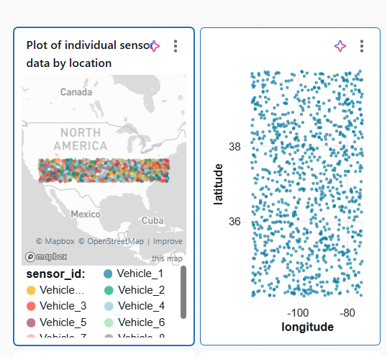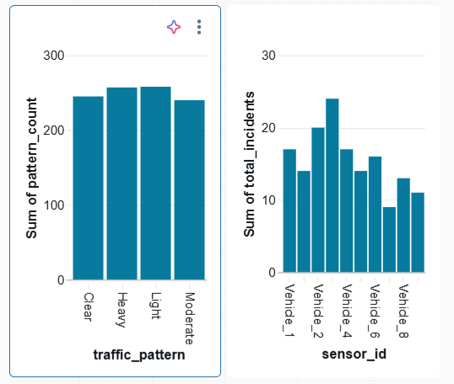

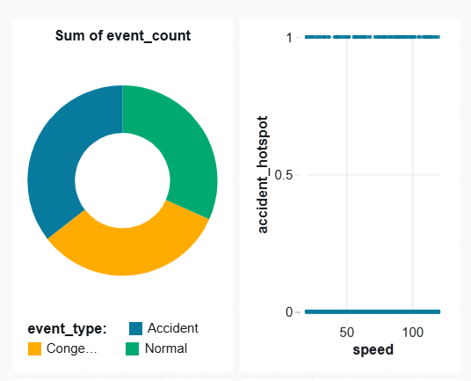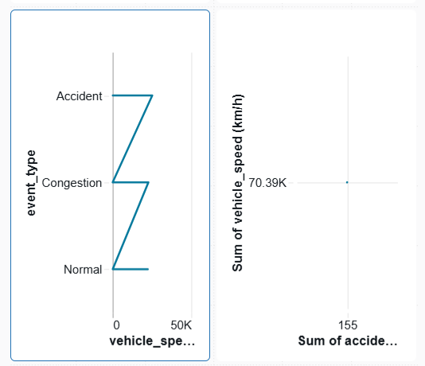

**Figure 2** illustrates the importance of **data integration** in generating deeper, multi-dimensional insights within the traffic congestion prediction system. By combining IoT-based traffic data with auxiliary datasets such as **weather conditions**, **road infrastructure**, **public event schedules**, and **population density**, analysts can uncover correlations that are often invisible in isolated data sources. For example, overlaying weather and event data on congestion maps reveals how rainfall, road maintenance, or major city events directly influence traffic buildup in specific regions. Such integrated analysis enables **transportation authorities** and **urban planners** to make informed decisions, such as optimizing signal timings, planning alternative routes, or deploying traffic personnel in advance during high-risk periods.

### 

### CHAPTER 7

### CONCLUSION

The **Traffic Congestion Prediction System** successfully demonstrates the potential of integrating **IoT technology** with **Big Data analytics** to address one of the major challenges in modern urban transportation — real-time traffic congestion management. By leveraging the power of the **Google Cloud Platform (GCP)**, the system provides an end-to-end solution for data ingestion, preprocessing, analytics, prediction, and visualization.

The project efficiently collects traffic data from multiple IoT sensors, processes it using scalable Big Data frameworks such as **Dataflow** and **BigQuery**, and applies **machine learning models** through **Vertex AI** to forecast congestion levels. The visualization and dashboard modules implemented using **Looker Studio** offer an intuitive way to monitor live traffic conditions and predicted congestion hotspots, thereby aiding authorities in making timely, data-driven decisions.

Through this system, it has been proven that the combination of **IoT-based data acquisition** and **cloud-enabled analytics** can significantly improve the accuracy and responsiveness of traffic management operations. The architecture ensures scalability, fault tolerance, and real-time performance, making it suitable for deployment in smart city environments.

In conclusion, the project establishes a robust framework for intelligent traffic analysis and prediction. It contributes to the broader goal of building sustainable and efficient transportation networks. The results indicate that adopting Big Data–driven IoT solutions can reduce congestion, optimize traffic flow, and improve the overall quality of urban mobility services.

### 

### CHAPTER 8

### FUTURE ENHANCEMENTS

Although the current **Traffic Congestion Prediction System** efficiently processes IoT-based traffic data and provides accurate congestion forecasts, there are several opportunities for further enhancement. Future improvements can focus on integrating additional data sources such as **satellite imagery**, **weather APIs**, **social media feeds**, and **GPS data from mobile devices** to enrich the dataset and enhance model accuracy. Incorporating these diverse data inputs would enable more precise and context-aware predictions under varying real-world conditions.

Another area for enhancement involves the implementation of **Edge Computing** to process data closer to the source, reducing latency and dependency on cloud infrastructure. This would allow faster response times and improved scalability for real-time congestion detection and alert systems. Additionally, **AI-driven adaptive traffic signal control** could be integrated to automatically adjust signal timings based on predicted congestion levels, improving road efficiency and minimizing delays.

Future versions of the system can also employ **advanced deep learning techniques**, such as **Graph Neural Networks (GNNs)** or **Hybrid LSTM–CNN architectures**, to better model spatial and temporal traffic dependencies. Moreover, developing a **mobile or web-based user interface** for commuters can provide real-time traffic updates and alternate route suggestions, enhancing public accessibility.

In the long term, the system can be expanded into a full **Smart City Traffic Management Platform**, integrated with other urban systems such as **public transport scheduling**, **emergency response routing**, and **environmental monitoring**. These enhancements would not only improve transportation efficiency but also contribute to sustainable urban development and smarter mobility ecosystems.

### REFERENCES

1. Chen, C., & Li, Y. (2022). Intelligent Traffic Flow Prediction Using IoT and Big Data Analytics. IEEE Transactions on Intelligent Transportation Systems, 23(5), 4221–4233. <https://doi.org/10.1109/TITS.2021.3098463>
2. Google Cloud Platform. (2023). Big Data Analytics Reference Architecture. Retrieved from <https://cloud.google.com/architecture>
3. Google Cloud. (2023). Vertex AI: Unified Machine Learning Platform. Retrieved from <https://cloud.google.com/vertex-ai>
4. Looker Studio (Google Data Studio). (2023). Data Visualization and Business Intelligence Platform. Retrieved from <https://lookerstudio.google.com/>
5. Chen, C., & Li, Y. (2022). Intelligent Traffic Flow Prediction Using IoT and Big Data Analytics. IEEE Transactions on Intelligent Transportation Systems, 23(5), 4221–4233. <https://doi.org/10.1109/TITS.2021.3098463>
6. Google Cloud. (2023). Vertex AI: Unified Machine Learning Platform. Retrieved from <https://cloud.google.com/vertex-ai>